**Form of Research Concept Paper**

**Research Topic …………**

Student’s name and ID …………………….

**Introduction**

An introduction is the part of paper that provides readers with the background of information for the research paper. It needs to create readers interest in the topic, establish the research problem that leads to the study. Moreover, the introduction part can encourage readers to read farther and to see the significance in the study.

* Current situation
* Problems
* Significant of this research
* Benefits

(The length of this part should be 1-2 short paragraphs)

**Research Questions (If needs)**

research problems of the research issue

**Research Objectives**

There are between 3-4 objectives but they have to answer the research problem of the research topic.

**Research hypothesis (If needs)**

The assumptions that you want to prove or find the answers.

(based on research problems/ questions/ objectives).

**Main Theory use/related research**

Identify the main theories that you want to use and related research.

**Research Design**

From research problem and research objectives, identify the suitable research design, with reason of using it.

1. Research type/strategy
2. Research steps with detail for each step including:

* Objective
* Variables and measurement
* Research tools
* Population, Sample size, sampling method
* Data analysis and expected results

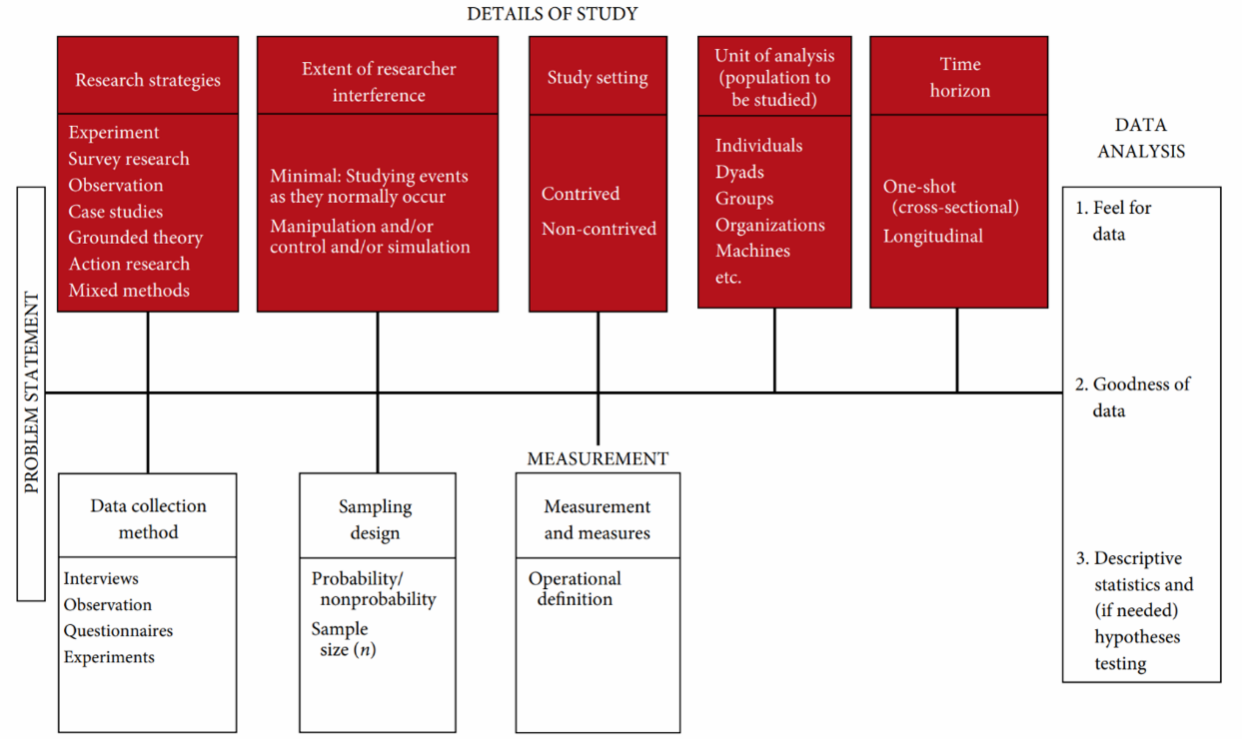

**Action plan**

Create a research action plan (Show time range of each step)

**Reason of doing this topic**

1. Is the topic in the field of Innovation management?
2. Is the topic novelty?
3. Does it contribute to the growth of Innovation management field?

*The number of the research concept paper is between 3-5 pages not includes references

* Insert page number in every page

**Reference**

30-50 literature review references